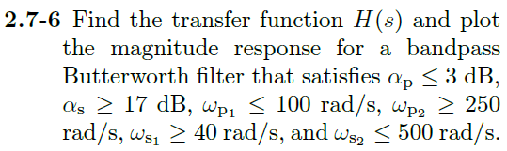

Copying example 2.12 from book:

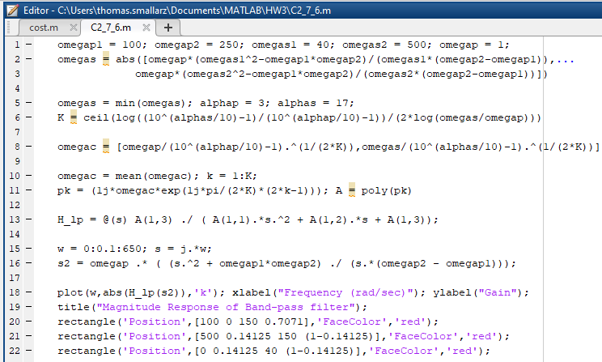

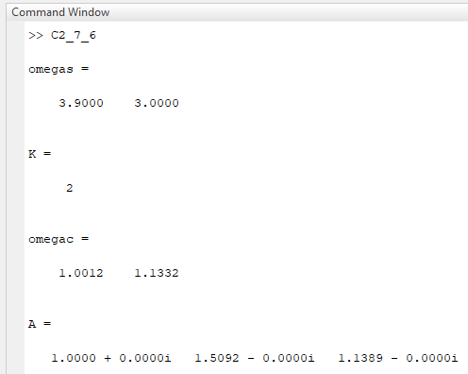

Therefore, our prototype LP Transfer Function is:

$$H_{lp}\left(s\right)=\frac{1.1389}{s^{2}+1.5092s+1.1389}$$

For lowpass to band pass transformation:

$$s_{2}=ω_{p}\frac{s^{2}+ω_{p1}ω_{p2}}{s(ω_{p2}-ω_{p1})}=\frac{s^{2}+25,000}{150s}$$

Then,

$$H_{bp}\left(s\right)=\frac{1.1389}{{\left(\frac{s^{2}+25,000}{150s}\right)}^{2}+1.5092\left(\frac{s^{2}+25,000}{150s}\right)+1.1389}$$

Then, plotted in MATLAB with constraints:

